Office Management System

Overview

Manage the use of on campus office space and keys for instructors and staff.

As determined by the chair or other administrator.

Programs

OM001 - OM099 database setup and listing programs Command line based

OM100 - OM199 Inquiry programs - Windows

OM200 – OM299 Maintenance programs - Windows

OM300 – OM399 assignment programs - Windows

OM400 – OM799 Unused

OM800 – OM899 = database programs

OM900 – OM999 Permission and other window related programs

Program # Description

**OM001**  create database

Create database on local machine

**OM010**  create database tables

Create tables on database

**OM020**  populate room table

Insert either test or production data into room table

**OM022**  populate instructor table

Insert either test or production data into instructor table

**OM024**  populate room / instructor table

Optional: insert instructor assigned to room into either the test or production database

Use the window program OM500 to assign instructor to room

**OM026**  populate key table

Insert either test or production data into key table

**OM028**  populate key / room table

Optional: insert key assigned to instructor into either test or production database

Use window program OM600 to assign key to instructor

**OM095**  dump selected table to output

Display selected table data to screen

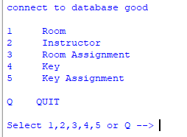

Select from menu to display contents of table

Note: output is displayed in IDLE shell

**OM099**  dump all tables to output

Display all tables to output

Note: output is displayed in IDLE shell

All window programs

All window program will attempt to open the database/

If successful, the window program will function

IF there is a problem with the database,

The following message box displays:

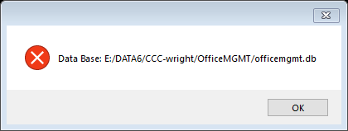

After selecting the “OK” button is selected.

Get the following message box:

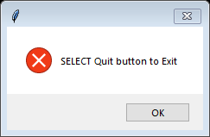

After selecting the “OK” button

Select the “QUIT” button on the screen/

Reason for the message boxes.

1. Program cannot find the database
2. Program cannot sign on to the database
3. Unknown database error

**OM100**  **Room Inquiry**

Lookup by room number, get information

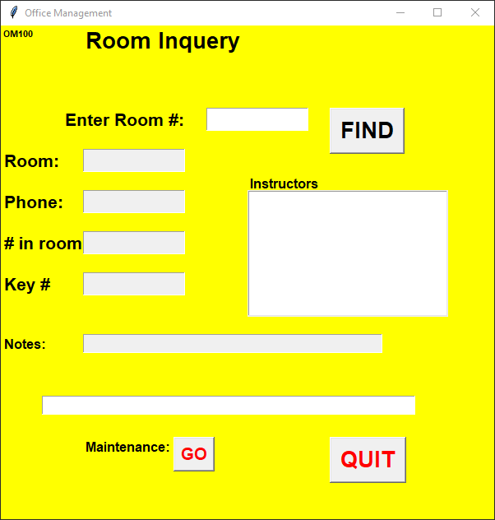

**Operation**

Type in room number in the “Enter Room#” box

If found: room number, phone number, # (number of staff) in room, key numbers,

Instructor assign to room and notes

If not found: message appears in bottom box

If you need to add or do maintenance to room,

Click on the “GO” buttom

GO button calls the Room maintenance program (OM200)

Room Number Found Room Not Found

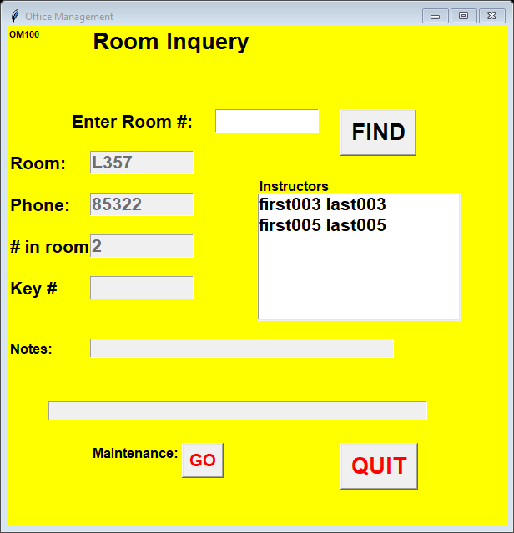 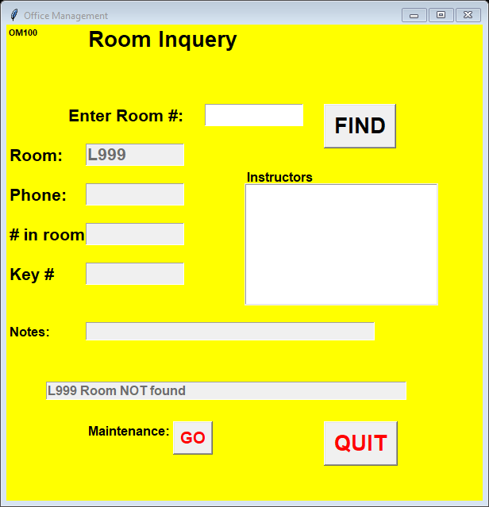

**OM120** **Instructor inquiry**

To be defined

Similar to room inquiry

**OM140** **Key inquiry**

**To be defined**

Similar to room inquiry

**OM200** **Instructor maintenance**

Add / Change / Delete instructor from database

**Operation**

Enter Instructor ID number in the “ID # Search” box and select the “Find” button

**If not found**,

the “Add” button is displayed

and the required fields are highlighted in green.

Once the fields are filled in, select the add button.

When the data is successfully added to the database, a message is displayed

**OM200 continue instructor maintenance**

**Add instructor**

The field highlighted in green must be filled in (cannot be blank)

Required fields (information):

* First Name
* Last Name
* Status (F-Full time, A-Adjunct, O-staff)

Optional:

* Middle name
* Notes

After “Add” button has been selected

Message is displayed that instructor is added to database

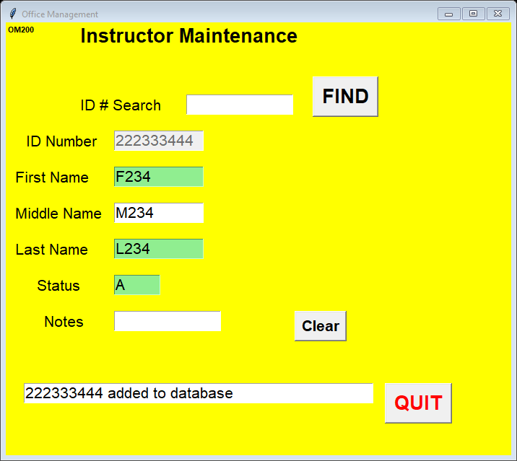

OM200 continue instructor maintenance

**If fields are not filled in:**

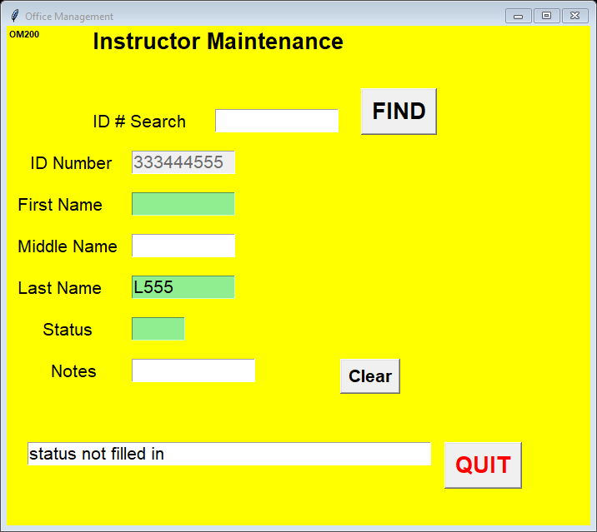

Message is displayed indicating the missing fileds

**If instructor number is found;**

The following buttons are displayed:

“Update” (change) the instructor information

“Delete” remove instructor from database

**Delete**

Delete Rules:

• Cannot be assigned to a room

• Cannot be assigned (have) keys

OM200 continue instructor maintenance

Select the “Delete” button to remove the instructor information from the database

A “Are you sure” message box is displayed

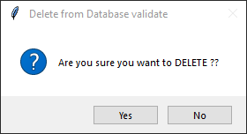

Select the “No” button and record IS NOT deleted.

The ‘cancel message’ is displayed.

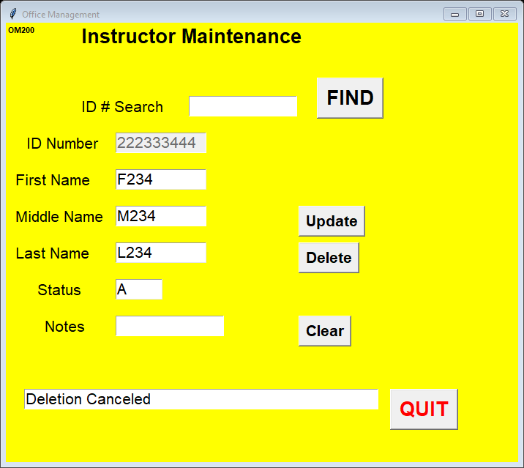

Select the “Yes” button and the record is deleted.

When the record is successfully deleted, a message is displayed.

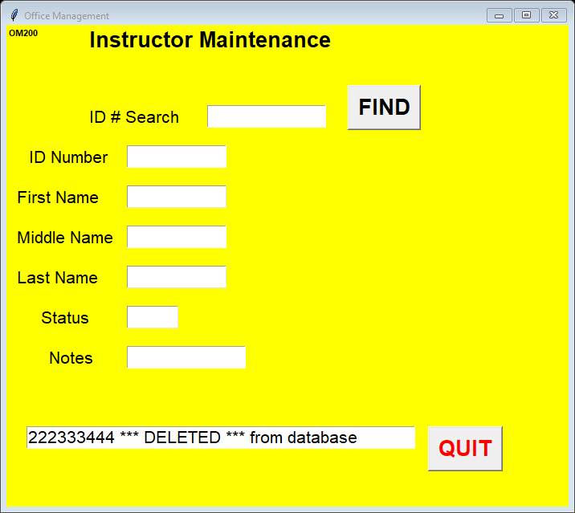

OM200 continue instructor maintenance

If the deletion of the record fails, a message will be issued as to possible cause of the failure.

Failure reason:

* Instructor assigned to a room
* Instructor assigned keys
* Database error

**Change (Update)**

The following fields can be changed:

* First Name
* Middle Name
* Last Name
* Status
* Note

The following fields can not be change to blank:

* First Name
* Last Name
* Status

OM200 continue instructor maintenance

Error fields will be highlighted in red and An error message will be displayed.

**Clear button**

Selecting the clear button will reset the window to the beginning.

All the boxes will be empty and ready for next instructor number.

Result of selecting the “Clear’ button

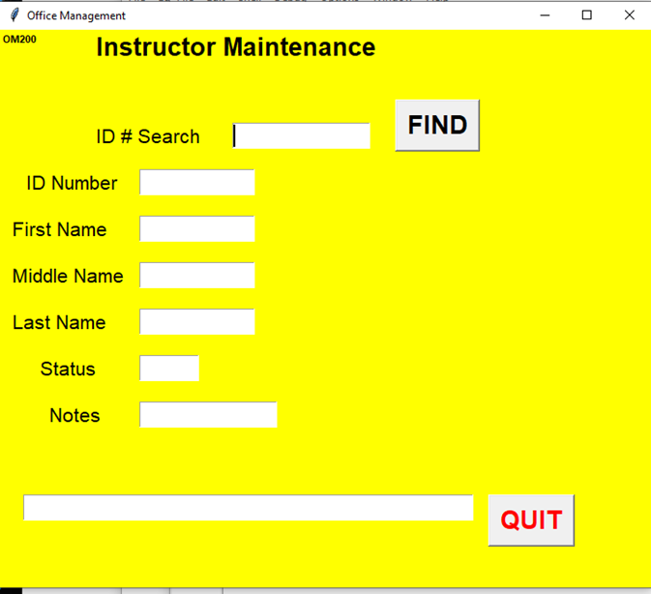

OM220 Room Maintenance

Add/change/delete room number from database

Add room

Change (update) or delete room number from database

OM220 continue

Delete:

Rules: cannot delete room if connected to a person

OM240 Key maintenance

Add/change/delete key (by number) from database

Add Key

Not ready

Change (update) or delete key

Not ready

Delete::

Not ready

Rules: cannot delete in connected to a person

OM300 Room assignment

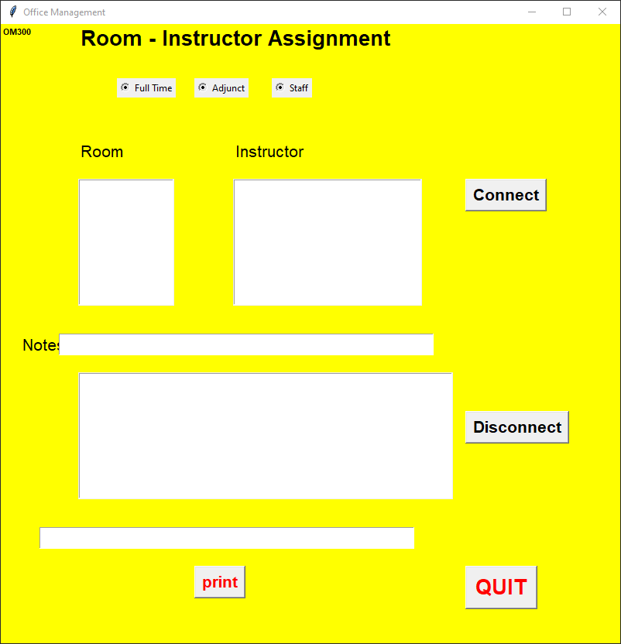

2

1 continue instructor maintenance

4

3

Select personnel type to connect (assign) to a room

Full time: Professor and other full time, one per room

Adjunct: All part time, up to 4 per room

Stall: NOT full time or adjunct no limit to room

ONLY one can be selected

Title of box changes based on selection (see #4)

OM300 Continue

When select button is clicked:

Full Time:

* List all Full Timers that are in an assigned room in lower box (Box #3)
* List rooms with nobody in then in left box (Box #1)
* List Full Timers not assigned a room in right box (Box #2)

Action: the connect and disconnect button work the same for all 3 categories

Adjunct:

* List all Adjuncts that are in an assigned room in lower box (Box #3)
* List rooms with less than 4 adjuncts in then in left box (Box #1)
* List Adjuncts not assigned a room in right box (Box #2)

Action: the connect and disconnect button work the same for all 3 categories

Stall:

* List Staff that are in an assigned room in lower box (Box #3)
* List rooms with staff in then in left box (Box #1)
* List staff not assigned a room in right box (Box #2)

Action: the connect and disconnect button work the same for all 3 categories

Action: Connect

To connect room to person, Highlight the room (only one) and highlight the person (only one)

And select the Connect button.

If successful, the connect is move to lower box (box #4)

And removed from left and right box ( box #1 and box #2)

OM300 continue room assignment

Disconnect

In the list in lower box (box #3), highlight the room / person.

Select the disconnect button

The highlighted will be removed from the lower box (box #3)

And the room and person will be added back the left and right box (box #1 & Box #2)

Rules:

Room must be on the room table

Person must be on the instructor table

Left box (box #1) and lower box (box #) will display room number order (sort by room number)

Right box (box #2) will display in alphabetic order

.

OM320 Key assignment

Similar to room assignment

Assign key to room

Not ready

Assign

Not ready

Unassign

Not ready

**OM800-899 database utilities**

OM800 select table (key, instructor or room)

List table contents to screen

OM820 List room assignment table to screen

OM840 list key assignment table to screen

**OM900 permission maintenance**

Set who can update the database

On the inquiry programs, the “go” button will not display if the person using the program does not have permission to make changes

The permission file is either a flat file or a single table on the database

Design to be determine (name & keyed by initials ?)

To Be defined

Print (to printer) request (actually write a flat file that can be used by excel or word)

Database maintenance (backup, create, etc)

Office management profile (configuration) file

Has number of adjuncts in office, path to database, etc

Create search window(s)